1GE + WIFI G/EPON ONU – HSGQ-G/E100W
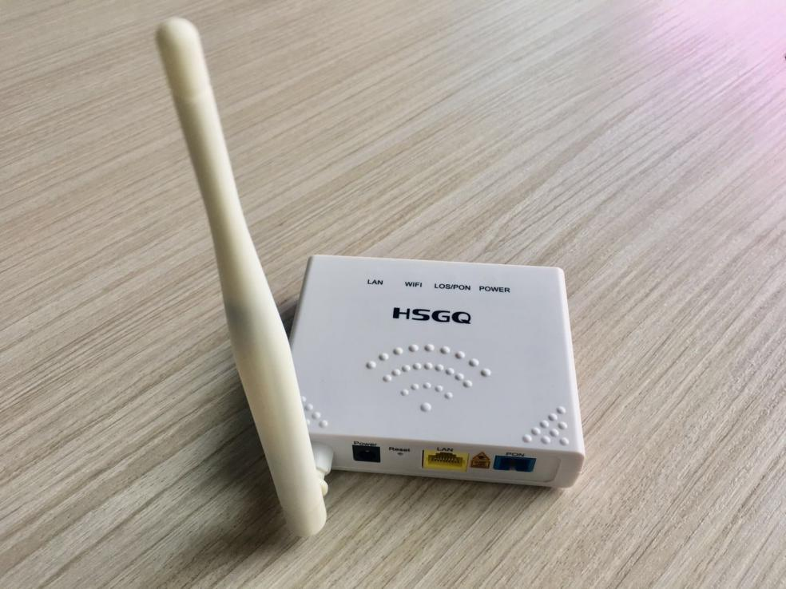
HSGQ 1GE WiFi G/EPON ONU HSGQ-G/E100W fully meet the ITU-T technical standards and have good compatibility with third party manufacturers OLT. 1GE WiFi G/EPON ONU HSGQ-G/E100W can integrate with 802.11b/g/n technical standards wireless function, It has built-in high gain directional antenna, the wireless transmission rate up to 300Mbps.
HSGQ 1GE WiFi G/EPON ONU HSGQ-G/E100W is one of the G/EPON optical network unit design to meet the requirement of the broadband access network. It apply in FTTH/FTTO to provide the data service based on the G/EPON network.
G/EPON is the latest generations of access network technology. ITU-T G.984 is the standard protocol of GPON. The G/EPON standard differs from other PON standards in that it achieves higher bandwidth and higher efficiency using larger, variable-length packets. G/EPON offers efficient packaging of user traffic, with frame segmentation allowing higher quality of service (QOS) for delay-sensitive voice and video communications traffic. G/EPON networks provides the reliability and performance expected for business services and provides an attractive way to deliver residential services. G/EPON enables Fiber To The Home (FTTH) deployments economically resulting to accelerated growth worldwide.
1GE WiFi G/EPON ONU HSGQ-G/E100W have a high reliability and provide quality of service guarantee、easy management, flexible expansion and networking. It’s fully meet the ITU-T technical standards and have good compatibility with third party manufacturers OLT.
1GE WiFi G/EPON ONU HSGQ-G/E100W can integration wireless function with meet 802.11b/g/n technical standards, It has built-in high gain directional antenna, the wireless transmission rate up to 300Mbps. It has the characteristics of strong penetrating power and wide coverage. It can provide users with more efficient data transmission security.

FUNCTIONAL FEATURE
- Support port-based rate limitation and bandwidth control;
- In compliant with ITU – T G.984Standard
- Wi-Fi meet 11 n/b/gtechnical standards
- Support data encryption, group broadcasting, port Vlan separation ,etc.
- Support Dynamic Bandwidth Allocation (DBA)
- Support ONU auto-discovery/Link detection/remote upgrade of software;
- Support port mode of VLAN configuration
- Support power-off alarm function ,easy for link problem detection
- Support broadcasting storm resistance function
- Support port isolation between different ports
- Support port flow control
- Support ACL and SNMP to configure data packet filter flexibly
- Specialized design for system breakdown prevention to maintain stable system
- Support software online upgrading
- EMS network management based on SNMP ,convenient for maintenance

Product Specification
Item | Parameter
PON Interface | 1*G/EPON port, FSAN G.984.2 standard, Class B+  Downstream Data Rate：2.488Gbps/1.244Gbps  Upstream Data Rate：1.244Gbps  SC/PC single mode fiber  28dB Link loss and 20KM distance with 1:128
User Ethernet  Interface | 1*10/100/1000M auto-negotiation  Full/half duplex mode  RJ45 connector  Auto MDI/MDI-X  100m distance
Power Interface | 12V DC Power supply
PON  Optical  Parameter | Wavelength: Tx 1310nm, Rx1490nm  Tx Optical Power: 0～5dBm  Rx Sensitivity: -28dBm  Saturation Optical Power: -8dBm  Connector Type: SC  Optical Fiber: 9/125μm single-mode fiber
Data Transmission  Parameter | PON Throughput: Downstream 2.488Gbit/s/1.244Gbps; Upstream 1.244Gbit/s  Ethernet: 100Mbps or 1000Mbps  Packet Loss Ratio: <1*10E-12 latency: <1.5ms
Business  Capability | Layer 2 wire speed switching  Support VLAN TAG/UNTAG，VLAN conversion  Support Port-based speed limitation  Support Priority classification  Support storm control of broadcast  Support loop detection
Network  Management | Support IEEE802.3 QAM, ONU can be remotely managed by OLT  Standard compliant OMCI interface as defined by ITU-T G.984.4  Support WEB management
Management  Function | Status monitor, Configuration management, Alarm management,  Log management
Shell | Plastic casing
Power | <4W, 12V/0.5A power supply adapter
Physical  Specifications | Item Dimension：135mm(L) x90mm(W) x 30mm (H)  Item weight：0.2kg  60.8*39.8*22.2 , 13kg/one carton （50pcs）
Environmental  Specifications | Operating temperature: 0 to 50ºC  Storage temperature: -40 to 85ºC  Operating humidity: 10% to 90%(Non-condensing)  Storage humidity: 10% to 90%(Non-condensing)

WIFI SPECIFICATION (SUITABLE FOR THE WIFI DEVICES)
Item |  | Parameter
Performance parameters | Operating Mode | Router or bridge
Performance parameters | Throughput | IEEE 802.11b: 11Mbps  IEEE 802.11g: 54 Mbps  IEEE 802.11n: 300Mbps
Performance parameters | Frequency | 2.412 ~ 2.472 GHz
Performance parameters | Channel | 13*Channel, configurable to meet the standard of USA, Canada, Japan and China
Performance parameters | Modulation | DSSS , CCK and OFDM
Performance parameters | Coding | BPSK, QPSK, 16QAM and 64QAM
Performance parameters | RF receive sensitivity | 802.11b:  -83dBm @ 1 Mbps; -80dBm @ 2 Mbps;  -79dBm @ 5.5 Mbps; -76dBm @ 11 Mbps  802.11g:  -85dBm @ 6 Mbps; -84dBm @ 9 Mbps;  -82dBm @ 12 Mbps; -80dBm @ 18 Mbps;  -77dBm @ 24 Mbps; -73dBm @ 36 Mbps;  -69dBm @ 48 Mbps; -68dBm @ 54 Mbps  802.11n 20MHz:  -74dBm @ 65 Mbps;  -70dBm @ 130 Mbps;  802.11n 40MHz:  -70dBm @ 135 Mbps;  -67dBm @ 300 Mbps;
Performance parameters | RF output lever | 802.11b:  17 ±0.5dBm @11Mbps  802.11g:  15 ±0.5dBm @ 54 Mbps; 16 ±0.5dBm @ 48 Mbps;  17 ± 1dBm @ 6 ~ 36 Mbps  802.11n 20MHz:  14 ± 0.5dBm @ 130 Mbps; 15 ± 0.5dBm @ 78 Mbps;  18 ± 0.5dBm @ 6.5 Mbps  802.11n 40MHz:  14 ± 0.5dBm @ 300 Mbps; 15 ± 0.5dBm @ 162 Mbps;  18 ± 0.5dBm @ 13.5 Mbps
Performance parameters | Encryption Mode | 802.11i security: WEP-64/128, TKIP (WPA-PSK) and AES (WPA2-PSK)

Network Application

- Typical Solution：FTTH, FTTO
- Typical Business：INTERNET, IPTV, VOD, IP Camera, WIFI
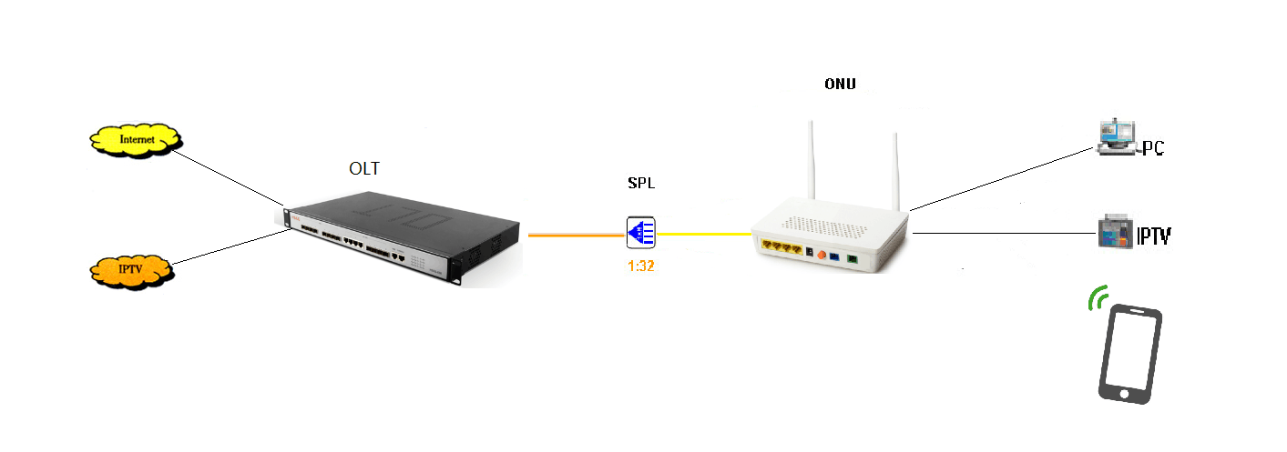

Ordering Information

Product Name | Product Model | Descriptions
1GE+WIFI | HSGQ-G/E100W | 1*10/100/1000M Ethernet interface, 1 G/EPON interface, Support 300Mpbs wifi ;plastic casing, external power supply adapter

