
HSGQ-G004 GPON OLT

HSGQ GPON OLT G004
Product Overview
G004 is a small-capacity cassette GPON OLT,meeting the requirements of ITU-T G.984/G.988 and relative standards of China Telecom/Unicom GPON,with super GPON access capacity,carrier-class reliability and the complete security function.It can satisfy long-distance optical fiber access requirement on account of its excellent management, maintenance and monitoring capability, abundant service features and flexible network mode.G004 can be used with network management system so as to provide users with the comprehensive access and perfect solution.
G004 provides 4 * downlink GPON port, 4*GE RJ45, 2 *GE SFP port and 2* 10G SFP+ port.The height is only 1U for easy installation and space saving.G004 is suitable for Broadcast three in one,video surveillance network, enterprise LAN, Internet of Things,etc.
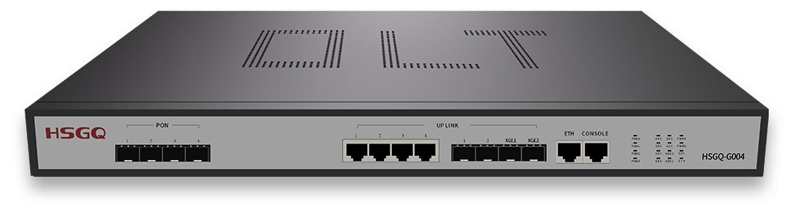
Product Specification:
Item | HSGQ-G004
Switching Capacity | 67Gbps
Forwarding Capacity(Ipv4/Ipv6) | 53.16Mpps
Service Port | 4*PON port, 4*GE RJ45 port, 2*GE SFP port, 2*10GE SFP+ port
Redundancy Design | Dual power supply can be choose  Support AC+AC, DC+DC, AC+DC input
Power Supply | AC: input 100～240V 50/60Hz
Power Consumption | ≤60W
Dimensions (Width x Depth x Height) | Net: 440mm×44mm×380mm Package:520mm*460mm*140mm
Weight (Full-Loaded) | Net: 4.6kg (Single AC power) Total: 6kg (Single AC power)
Environmental Requirements | Working temperature: -10°C～55°C  Storage temperature: -40°C～70°C  Relative humidity: 10%～90%, non-condensing

Product Features:
HSGQ-G004 GPON OLT
Item |  | V1.0.0
PON Features |  | ITU-T G.984.x/G.988;  SN / LOID / LOID+LOID Password authentication modes;  Terminal access up to 20km on a single fiber;  1: 128 split ratio on single PON port ;  DBA algorithm, and the particle is for 64Kbit/s;  Standard OMCI management function;  ONU batch software upgrade;  PON port optical parameter detection;  Auto registration ONU bound with default profile
L2 Features | MAC | MAC Black Hole;  Port MAC Limit;  64K MAC (packet exchange chip cache 2MB );
L2 Features | VLAN | 4K VLAN entries;  Port-based VLAN classification;  Uplink VLAN Swap and VLAN Remark;
L2 Features | Spanning Tree | STP/RSTP/MSTP  loop detection
L2 Features | Port | Support link aggregation;  Port mirroring;
L2 Features | Service-Port | Auto configuration service-port by profile  VLAN transparent/tag/stack/aggregation
Security  Features | User’s Security | Anti-ARP-spoofing;  Anti-ARP-flooding;  Port Isolation;  MAC address binding to the port and MAC address filtering;
Security  Features | Device Security | Support the control layer to prevent a variety of DOS attacks and virus attacks against the CPU;  SSHv2 Secure Shell;  Login Security IP via Telnet;  Hierarchical management and password protection of users;
Security  Features | Network Security | User-based MAC and ARP traffic examination;  Restrict ARP traffic of each user and force-out user with abnormal ARP traffic;  Dynamic ARP table-based binding;  IP+VLAN+MAC+Port binding;  L2 to L7 ACL flow filtration mechanism on the 80 bytes of the head of user-defined packet;  Port-based broadcast/multicast suppression and auto-shutdown risk port;  DHCP Option82 and PPPoE+ upload user’s physical location
Service Features | ACL | Standard and extended ACL;  Time Range ACL;  Flow classification and flow definition based on source/destination MAC address, VLAN, 802.1p, ToS, DiffServ, source/destination IP(IPv4/IPv6) address, TCP/UDP port number, protocol type, etc;  packet filtration of L2～L7 deep to 80 bytes of IP packet head;
Service Features | QoS | Rate-limit to packet sending/receiving speed of port or self-defined flow and provide general flow monitor and two-speed tri-color monitor of self-defined flow;  CAR(Committed Access Rate),Traffic Shaping and flow statistics;  Packet mirror and redirection of interface and self-defined flow;  Supports priority marking of ports or custom flows and provides 802.1p, DSCP-priority Remark capability;  Super queue scheduler based on port or self-defined flow. Each port/flow supports 8 priority queues and scheduler of SP, WRR and SP+WRR;  Congestion Avoidance Mechanism, including Tail-Drop and WRED;
Service Features | IPv4 | DHCP Relay;  DHCP Server;  DHCP Snooping;  Static Routing;
Service Features | Multicast | IGMPv1/v2 Snooping;  IGMP Fast leave;  IGMP Proxy;  Compatible with IGMP v3
Reliability | Loop Protection | Loopback detection;
Reliability | Link Protection | RSTP/MSTP (recover-time <1s);  Link aggregation (recover-time <10ms);
Reliability | Device Protection | 1+1 power hot backup;
Maintenance | Network Maintenance | Port real-time, utilization and transmit/receive statistic  Powerful WEB GUI  GPON OMCI;  Data Logging and RFC 3164 BSD syslog protocol;  Ping diagnosis
Maintenance | Device Management | Console port, Telnet, SSH management;  Out-band management;  SNMPv1/v2  RMON (Remote Monitoring)1,2,3,9 groups MIB;  SNTP;  Fan management
HSGQ-G004 GPON OLT

HSGQ-G016 GPON OLT

