SFP Single Mode Fiber BIDI Transceiver

40km

Product Features

Uncooled Laser Diode with MQW Structure

InGaAs PIN-TIA Photodiode Receiver

Reach 40 km Transmission Distance on 9/125μm SMF BIDI Single Mode Transceiver SFP Footprint
LC Or SC Optical Interface Are Optional

Compliant With SFP MSA and SFF-8472

Digital Diagnostic Monitoring Interface

Single +3.3V Power Supply

CML Differential Inputs and Outputs

LVTTL Signal Detection Output

Compliant With ITU-T G.957

Compliant With RoHS and Lead Free

Metal Enclosure for Lower EMI Operating Case Temperature:
Standard: 0 to +70°C Extend: -20 to +85°C Industrial: -40 to +85°C

Product Applications

Gigabit Ethernet

Fiber Channel

ATM/SONET/SDH/Switch/Router

Other Optical Transmission Systems

General Description

The SFP transceivers are high performance, cost effective modules supporting data-rate of 155Mbps or 1.25Gbps and 40km transmission distance on 9/125μm SMF.

The transceiver consists of three sections: a DFB laser transmitter, a PIN photodiode integrated with a trans-impedance preamplifier (TIA) and DDMI control unit. All modules satisfy class I laser safety requirements.

The transceivers are compliant with the Small Form-Factor Pluggable (SFP) Multi-Source Agreement (MSA) and SFF-8472. For further information, please refer to SFP MSA.

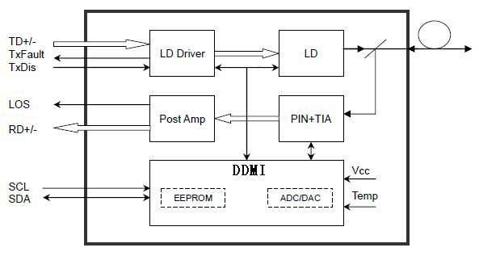

Transmitter Section

Transmitter is designed for single mode fiber and operates at a nominal wavelength of
1370nm or 1510nm. The transmitter module uses a DFB laser diode and full IEC825 and CDRH class 1 eye safety. The output power can be disabled via the single
TX-disable pin. Logic LVTTL HIGH level disables the transmitter. It contains APC function, temperature compensation circuit, PECL data inputs, LVTTL TX-disable input and TX-fault Output interface.

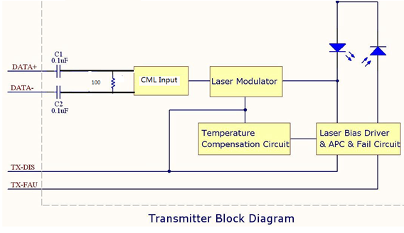

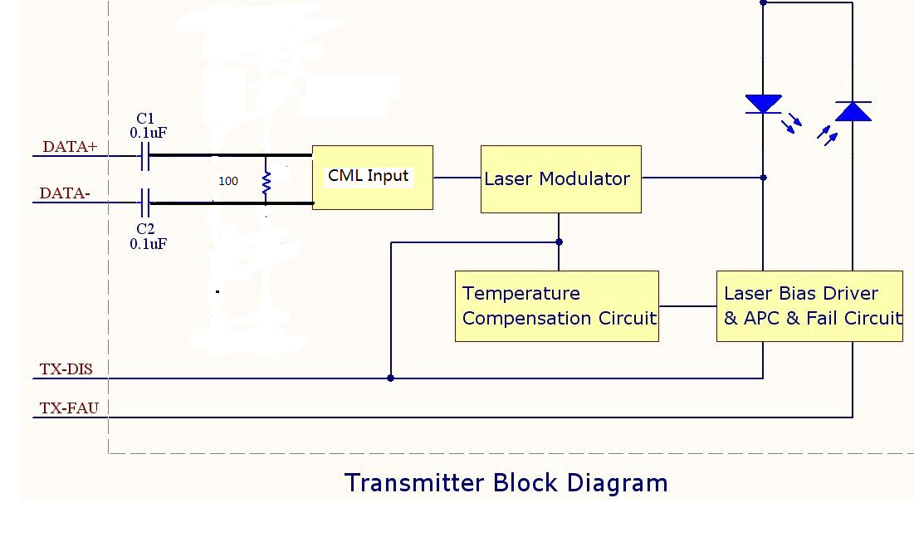
Receiver Section

The receiver section uses a hermetic packaged front end receiver ( InGaAs PIN and preamplifier). The post amplifier is AC coupled to preamplifier through a capacitor and a low pass filter. The capacitor and LPF are enough to pass the signal from 50Mb/s to 1300Mb/s without significant distortion or performance penalty. The LPF limits the preamplifier bandwidth to improve receiver sensitivity. As the input optical is decreased, LOS will switch from low to high. As the input optical power is increased from very low levels, LOS will switch back from high to low.

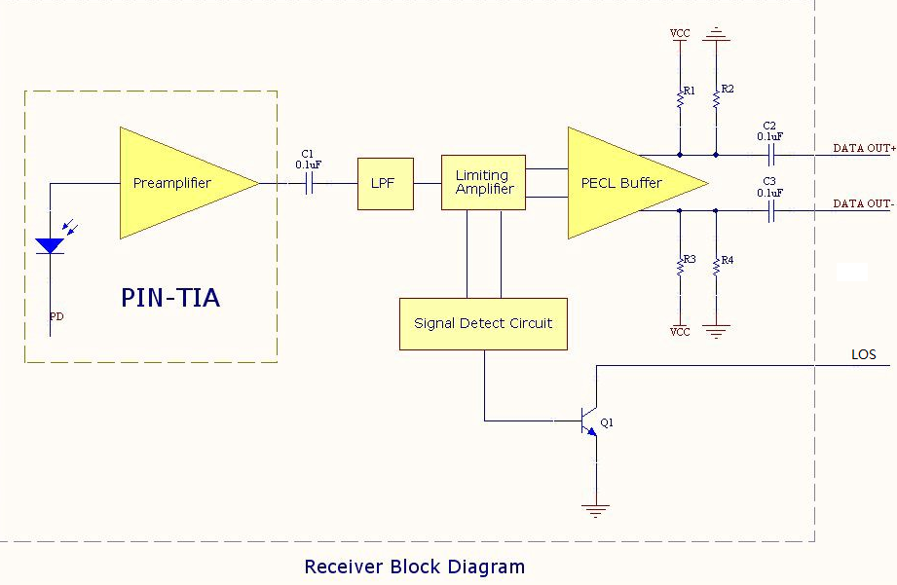

DDMI Section

The DDMI contains an EEPROM. It provides access to sophisticated identification information that describes the transceiver’s capabilities, standard interfaces, manufacturer, and other information.
The serial interface uses the 2-wire serial CMOS EEPROM protocol defined for the 24C02. When the serial protocol is activated, the host generates the serial clock signal (SCL, Mod Def 1). The positive edge clocks data into those segments of the EEPROM that are not write protected within the SFP transceiver. The negative edge clocks data from the SFP transceiver. The serial data signal (SDA, Mod Def 2) is
bi-directional for serial data transfer. The host uses SDA in conjunction with SCL to mark the start and end of serial protocol activation. The memories are organized as a series of 8-bit data words that can be addressed individually or sequentially.

The Module provides diagnostic information about the present operating conditions. The transceiver generates this diagnostic data by digitization of internal analog signals. Calibration and alarm/warning threshold data is written during device manufacture. Received power monitoring, transmitted power monitoring, bias current monitoring, supply voltage monitoring and temperature monitoring all are implemented. The diagnostic data are raw A/D values and must be converted to real world units using calibration constants stored in EEPROM locations 56 – 95 at wire serial bus address A2h. The digital diagnostic memory map specific data field defines as following.

Memory Map

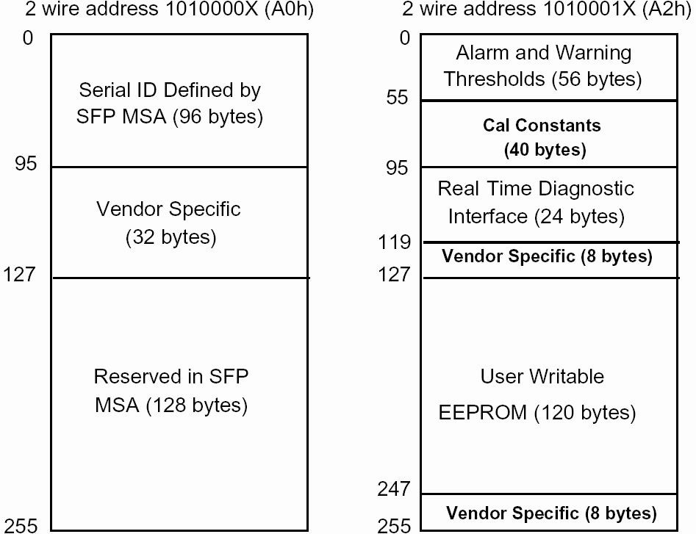

Performance Specifications

Absolute Maximum Ratings
Parameter | Symbol |  | Min | Max | Unit
Storage Temperature | Tst |  | -40 | +85 | °C
Operating Temperature | TO |  | -20 | +75 | °C
Input Voltage | - |  | GND | VCC | V
Power Supply Voltage | VCC-VEE |  | 0 | +3.6 | V
Note: Stress in excess of maximum absolute ratings can cause permanent damage to the module

Recommended Operating Conditions
Parameter | Symbol |  | Min | Typ | Max | Unit
Storage Temperature | Tst |  | -40 | - | +85 | °C
Operating Case Temperature | TC | OFP2 | 0 | - | +70 | °C
Operating Case Temperature | TC |  |  | - |  | °C
Operating Case Temperature | TC |  |  | - |  | °C
Power Supply Voltage | VCC |  | 3.1 | 3.3 | 3.5 | V
Power Supply Current | ICC |  | - | - | 300 | mA
Data Rate | DR |  | 0.05 | 1.25 | 1.3 | Gbps

Optical Specification
Transmitter
Parameter |  |  |  |  | Symbol | Min | Typ | Max | Unit | Note
Center Wavelength |  |  |  | 1370 DFB | λC | 1362.5 | 1370 | 1377.5 | nm  nm | CWDM  CWDM
 |  |  |  | 1510 DFB | λC | 1502.5 | 1510 | 1517.5 | nm | CWDM  CWDM
Spectral Width |  |  |  | DFB | Δλ | - | - | 1 | nm | -
Side Mode Suppression Ratio |  |  |  |  | SMSR | 30 | - | - | dB | DFB Laser
Average Optical Output Power |  |  | 1370nm TX |  | Po | -3 | - | 2 | dBm | -
 |  |  | 1510nm TX |  | Po | -5 |  | 2 | dBm
Extinction Ratio |  | 1.25Gbps |  |  | ER | 9 | - | - | dB
 |  | 155Mbps |  |  | ER | 10 |  |  | dB
Optical Rise/Fall Time  (20%-80%) for 155Mbps product |  |  |  |  | Tr/Tf | - | - | 2 | ns
Optical Rise/Fall Time  (20%-80%) for 1.25Gbps product |  |  |  |  | Tr/Tf | - | - | 0.28 | ns | -
Output Eye Diagram |  |  |  |  | Compliant with ITU-T G.957
Receiver
Parameter |  |  |  |  | Symbol | Min | Typ | Max | Unit | Note
Operate Wavelength |  |  |  | 1510 | - | 1500 | 1510 | 1570 | nm
 |  |  |  | 1370 | - | 1291 | 1370 | 1480 | nm
Receiver Sensitivity for 155Mps product |  |  |  |  | RSENS | - | - | -34 | dBm | 1
Receiver Sensitivity for 1.25Gbps product |  |  |  |  | RSENS |  |  | -24 | dBm | 1
Receiver Saturation |  |  |  |  | PRS | -3 | - | - | dBm | 1
LOS Assert | 1.25Gbps |  |  |  | - | -35 | - | - | dBm | Alarm: High-level
LOS Assert | 155Mbps |  |  |  |  | -47 |  |  | dBm | Alarm: High-level
LOS De-Assert | 1.25Gbps |  |  |  | - | - | - | -24 | dBm | Alarm: High-level
LOS De-Assert | 155Mbps |  |  |  |  |  |  | -34 | dBm | Alarm: High-level
LOS Hysteresis |  |  |  |  | - | 0.5 | - | 5 | dBm | -
Note: 1. Minimum Sensitivity and saturation levels for a 27-1 PRBS test pattern @1.25G bps.
Minimum Sensitivity and saturation levels for a 223-1 PRBS test pattern @155M bps.

Electrical Specification

Transmitter
Parameter |  | Symbol | Min | Typ | Max | Unit | Note
Power Supply Current |  | ICCT | - | 70 | 160 | mA | 2
Input Differential Impedance |  | ZIN | 90 | 100 | 110 | Ω | -
Input Swing Differential Voltage |  | VIN | 350 | - | 1600 | mV | 3
TX-Disable Voltage | Disable | - | 2.0 | - | VCC | V | -
TX-Disable Voltage | Enable | - | 0 | - | 0.8 | V | -
TX-Fault Voltage | Fault | - | 2.0 | - | VCC | V | -
TX-Fault Voltage | Normal | - | 0 | - | 0.8 | V | -
Receiver
Parameter |  | Symbol | Min | Typ | Max | Unit | Note
Power Supply Current |  | ICCR | - | 70 | 150 | mA | 2
Output Swing Differential Voltage |  | VOUT | 350 | - | 1600 | mV | 4
LOS Voltage | High | - | 2.0 | - | VCC | V | -
LOS Voltage | Low | - | 0 | - | 0.8 | V | -
Note: 2. The current excludes the output load current.

3. CML input, internally AC-coupled and terminated.

4. Internally AC-coupled.

Diagnostics Specification

Parameter | Range | Unit | Accuracy | Calibration
Temperature | 0 to +70 | °C | ±3 | Internal/External
Temperature | -40 to +85 | °C | ±3 | Internal/External
Voltage | 3.0 to 3.6 | V | ±3% | Internal/External
Bias Current | 0 to 100 | mA | ±10% | Internal/External
TX Power | -5 to 2 | dBm | ±3 | Internal/External
RX Power | -25 to -3 for 1.25Gbps | dBm | ±3 | Internal/External
RX Power | -34 to -8 for 155Mbps | dBm | ±3 | Internal/External

Pin Definitions

PIN Diagram

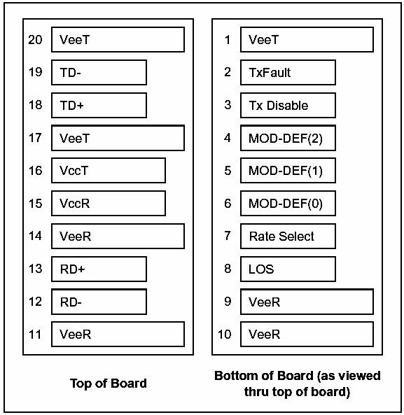

PIN Description

PIN | Name | Description | Notes
1 | VEET | Transmitter Ground | -
2 | TX FAULT | Transmitter Fault Indication | Note 1
3 | TX DISABLE | Transmitter Disable | Note 2
4 | MOD_DEF(2) | SDA Serial Data Signal | Note 3
5 | MOD_DEF(1) | SCL Serial Clock Signal | Note 3
6 | MOD_DEF(0) | Module Absent. Grounded within the module | Note 3
7 | Rate Select | Not Connected | -
8 | LOS | Loss of Signal | Note 4
9 | VEER | Receiver ground | -
10 | VEER | Receiver ground | -
11 | VEER | Receiver ground | -
12 | RD- | Inv. Received Data Out | Note 5
13 | RD+ | Received Data Out | Note 5
14 | VEER | Receiver ground | -
15 | VCCR | Receiver Power Supply | 3.3V±5%
16 | VCCT | Transmitter Power Supply | 3.3V±5%
17 | VEET | Transmitter Ground | -
18 | TD+ | Transmit Data In | Note 6
19 | TD- | Inv. Transmit Data In | Note 6
20 | VEET | Transmitter Ground | -

Notes:
1) TX Fault is an open collector output, which should be pulled up with a 4.7k~10kΩ resistor on the host board to a voltage between 2.0V and Vcc+0.3V. Logic 0 indicates normal operation; Logic 1 indicates a laser fault of some kind. In the low state, the output will be pulled to less than 0.8V.
2) TX Disable is an input that is used to shut down the transmitter optical output. It is pulled up within the module with a 4.7k~10kΩ resistor. Its states are:
Low (0 to 0.8V): Transmitter on
(>0.8V, < 2.0V): Undefined
High (2.0 to 3.465V): Transmitter Disabled
Open: Transmitter Disabled
3) Mod-Def 0,1,2. These are the module definition pins. They should be pulled up with a 4.7k~10kΩ
resistor on the host board. The pull-up voltage shall be VCCT or VCCR.
Mod-Def 0 is grounded by the module to indicate that the module is present
Mod-Def 1 is the clock line of two wire serial interface for serial ID Mod-Def 2 is the data line of two wire serial interface for serial ID
4) LOS is an open collector output, which should be pulled up with a 4.7k~10kΩ resistor. Pull up voltage between 2.0V and Vcc+0.3V. Logic 1 indicates loss of signal; Logic 0 indicates normal operation. In the low state, the output will be pulled to less than 0.8V.
5) RD-/+: These are the differential receiver outputs. They are internally AC-coupled 100Ω
differential lines which should be terminated with 100Ω (differential) at the user SERDES.
6) TD-/+: These are the differential transmitter inputs. They are internally AC-coupled, differential lines with 100Ω differential termination inside the module.

Recommended Circuit

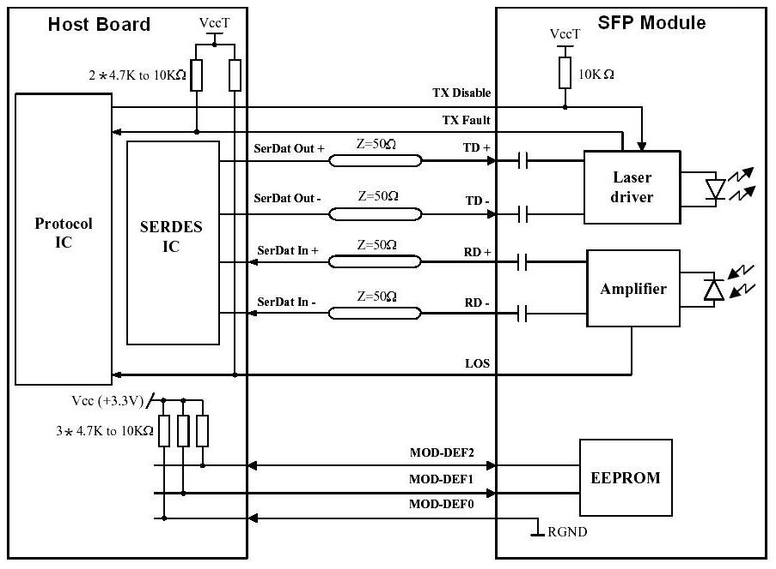

Package Diagram

Board Layout Hole Pattern

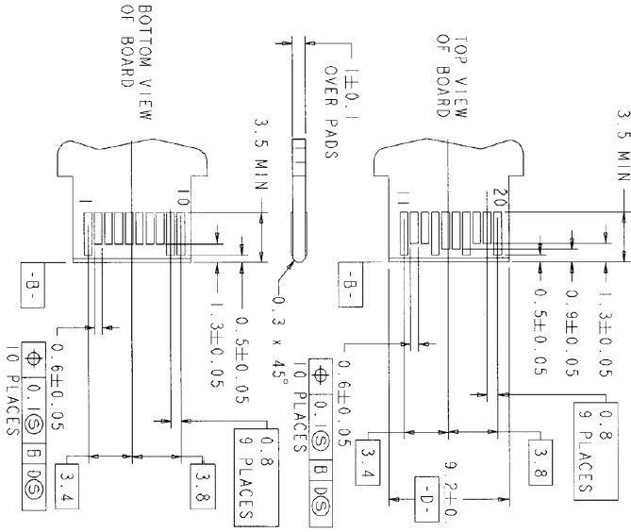

LC Side Interface

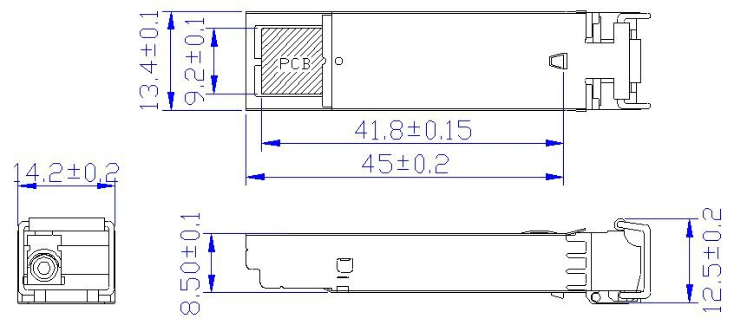

SC Side Interface

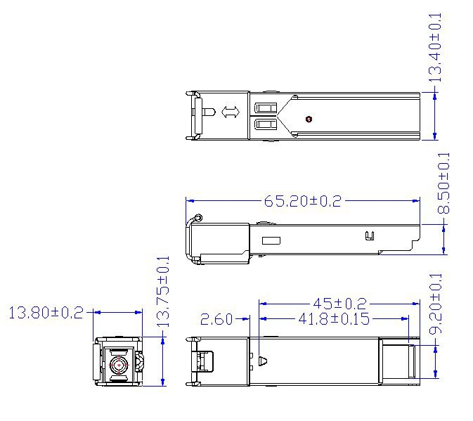

Order Information
Part No. | Wavelength | Data rate | Connector | Temp. | TX Power  (dBm) | RX Sens (Max.)  (dBm) | Distance
OFP2-FM03-4CY1 | Tx1370DFB/Rx1510 | 155M | LC | 0 to 70 | -3 to +2 | -34 | 40km
OFP2-MF03-4CY1 | Tx1510DFB/Rx1370 | 155M | SC | 0 to 70 | -5 to +2 | -34 | 40km
OFP2-FM24-4CY1 | Tx1370DFB/Rx1510 | 1.25G | LC | 0 to 70 | -3 to +2 | -24 | 40km
OFP2-MF24-4CY2 | Tx1510DFB/Rx1370 | 1.25G | SC | 0 to 70 | -5 to +2 | -24 | 40km

Revision History: Rev. 0.0
Previous Version:
Page | Subjects (major changes since last revision)

For more information:

SHENZHEN OMIS OPTICAL COMMUNICATION TECHNOLOGY CO. ,LTD
http://www.the-omis.com

Tel: +86-755-89582791

Fax: +86-755-89582791

